Review for Physiology Benchmark Quiz
Define each system with its organs and function.
- Nervous System-
- Identify the difference between the Central Nervous System and the Peripheral Nervous System by labeling each.
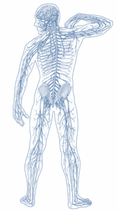
- Sensory Neuron-

- Interneuron-

- Motor Neuron-

- ID and label each of the Neurons in this Reflex response. Is the brain involved?
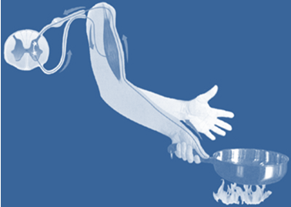
- ID and label the parts of a Neuron
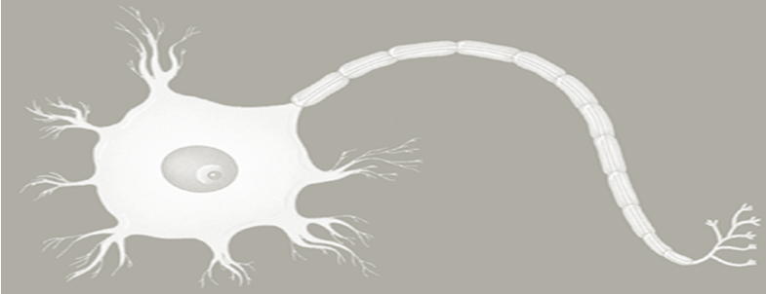
- How does a nerve impulse travel?
- Immune System-

- What is AIDS? How is HIV transmitted? Do people die from AIDS?

- What is a Pathogen and how is its survival different between day 1 and day 10? What happened? What microorganism is this person infected with if they are taking Penicillin?

Penicillin Treatment
Day | Dose | % of Pathogen Survival
1 | 500 mg | 80%
2 | 500 mg | 50%
3 | 500 mg | 30%
4 | 500 mg | 10%
5 | 0 mg | 15%
6 | 0 mg | 25%
7 | 0 mg | 40%
8 | 0 mg | 60%
9 | 500 mg | 55%
10 | 500 mg | 65%
Figure 39-1
- How can a fever or runny nose be beneficial to curing an infection from a pathogen?

- What pathogen is not live and cannot make its own proteins?

- What is a vaccine?
- Endocrine System-

- What is Adrenaline? And where is it secreted from?

- How does this picture show a Negative Feedback System?

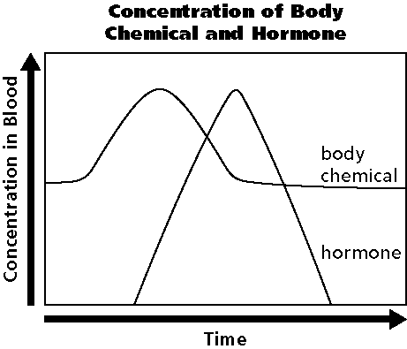

- What triggered the Hormone production in this picture?

- Circulatory System-

- What are the four blood types? What blood type is the universal donor? What blood type is the universal recipient?

- Digestive System-

- In order to maintain ________________ in the digestive system, when there is an intake of food then there must be waste removal.

- Respiratory System-

- Urinary/ Excretory-

- Integumentary System-

