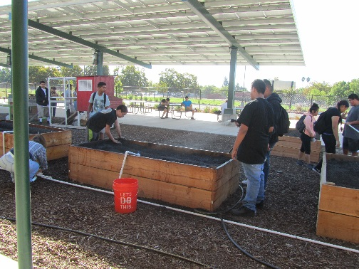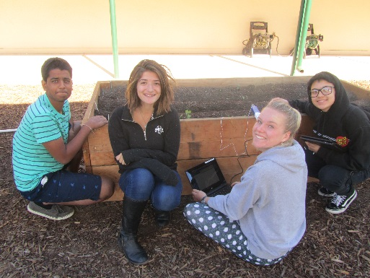**Ag Biology/ Farm to Fork 1 & 2**

**McAllister, Bryte CCT**

**Survey of Agricultural Experience**

Name: __________________________________ Course: ___________________ Grade: ______

1. Give an example of a time when you did something related to Agriculture: Garden, State Fair, Farmer’s Market, been to the Farm to Fork Festival, ….

________________________________________________________________________________________________________________________________________________________________________

1. Finish the sentence: My family (aunts, uncles, grand parents, etc.) live in ______________________

and are involved in Agriculture by _______________________________________________________.

1. Please read the following sentence. Circle the answer(s) or please fill in the blank to the sentence. I have family members who: Own land, have animals, raise livestock, garden, do construction,

___________________________________________________________________________________.

1. My family works for a business, and it is related to agriculture by: ____________________________________________________________________________________
2. My expectation of this Ag Biology class is: ________________________________________________________________________________________________________________________________________________________________________
3. Mrs. McAllister, This is what you need to know about me: ________________________________________________________________________________________________________________________________________________________________________
4. Mrs. McAllister, I am here because:

________________________________________________________________________________________________________________________________________________________________________