Lab: Natural Selection of Bird Beaks
Background Information:
Natural Selection is a mechanism of evolution. Competitiion for food can be a driving force of natural selection. In order for natural selection to occur, the following must be present (using beetles as an example):
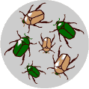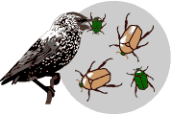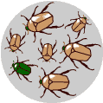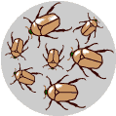
________________ → _______________________--> _________________--> __________________
Questions:
How does the environment and the food available in that environment affect which species of birds live where? ______________________________________________________________________________
Why does the environment act on the phenotype rather than the genotype? _____________________________________________________________________________________
Procedures:
Part 1 You will use one beak per team (scissors, chopsticks, clothespins, plastic spoons, scoopulas or tweezers) to simulate eating different kinds of prey (popcorn kernels, beans, toothpicks, paper clips, rubber bands, packing material,rice, peas,wheat, sun flower seeds).
- Each person will act as a “predator”. Using your hand to hold your beak, pick up as many prey items as you can during the 15 second time limit. Use only your beak, and pick up only ONE PREY AT A TIME.
- After 15 seconds, record the number of prey you caught and the total caught by your whole group in Data table 1. Return the prey items to the feeding tray.
- Calculate the average yield by dividing the total number of prey items by the number of predators. (Each member of your group counts as one predator).
Data Table 1 BEAK TYPE __________________________________
Prey type | # Prey You Caught | Total # for Team | Average Yield  (Total/ # predators)
Popcorn Kernels
Packing Material
Toothpicks
Paper Clips
Rubber Bands
Small Red Beans
Sunflower Seeds
Wheat
Lentils
Rice

The environment changes and as a result there are different prey types, and some prey types do not exist anymore. Cross out Small Red Beans, Lentils, and Rice
Conclusion Questions:
- What tools did you and your partner have? Did either one seem to work better? Explain.

- What were the advantages of your beak? Disadvantages?
- Which “Food source(s)’ were you able to grasp easily? Why?
- Which “food source(s) were difficult to grasp? Why?
- How does this activity mimic how birds that habitat islands live?
- Based on the findings of this lab, do you think it is good to have variation in a species? Explain and give some examples.

- How does variation play a key role when the environment changes?

