Name:
The Atmosphere Notes 2

COMPOSITION: What gases our Atmosphere is Made of

______________________: ________%

______________________: ________%

______________________: ________%

______________________: ________%

OTHER GASES: GREENHOUSE GASES

What do greenhouse gases do?_________________________________________

____________________________________________________________________________

TOP 3 GREENHOUSE GASES
- ___________________
- ___________________
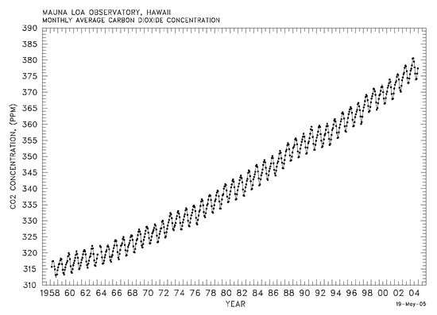
- ___________________

In California, about how much temperature increase have we seen already? ______________
What areas have increased the most? ________________________________
How much do we predict we could see in California in 2070? ______

How is Venus’s Atmosphere similar to Earth’s?

__________________________________________________________________________
How is Venus’s Atmosphere different than Earth’s?

_______________________________________________________________________
WILL VENUS BE HOTTER OR COLDER THAN EARTH?
_______________________________________________________________________
_______________________________________________________________________
How is Mar’s Atmosphere similar to Earth’s?

__________________________________________________________________________
How is Mar’s Atmosphere different than Earth’s?

__________________________________________________________________________
WILL MARS BE HOTTER OR COLDER THAN EARTH?
_______________________________________________________________________
_______________________________________________________________________
_______________________________________________________________________

SUMMARY: ____________________________________________________________________________________________________________________________________________________________________________________________________________________________________________________________________________________________________________________________________________________________________________________________

