NAME:
IMAGINARY CONTINENT

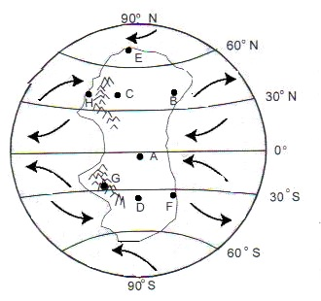

NAME:
IMAGINARY CONTINENT

We’ve talked about Altitude (Height), Closeness to Water, Closeness to Mountains, and Latitude as factors that can affect climate. The wind directions are given to help you determine Windward and Leeward sides of mountain ranges.

Step 1: Color in the Tropical, Temperate, and Polar regions
Step 2: Identify the General Temperature, Temperature Range, and General Precipitation for EACH of the
marked positions on the map.
Step 3: Write a justification to EXPLAIN YOUR DECISION!

 | General Temperature  (Hot, Cold, or Moderate) | Temperature Range  (Small range, Large Range | Precipitation  (Dry, Wet, or Moderate) | JUSTIFICATION  (Explain your decision)
Example | Cold | Large Range | Wet | “Example” will have a cold temperature because it is in the polar latitude region and on a mountain. …….
A
B
C
D
E
F
G
H

