Name:
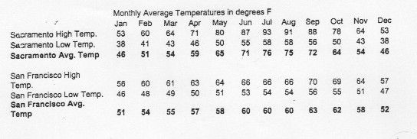
Graph the following data for Sacramento and for San Francisco. You will end up with 3 lines, one for “HIGH”, “LOW”, “AVERAGE”.

SACRAMENTO V. SANFRANCISCO QUESTIONS

- Which City is closer to water?
Sacramento or SanFrancisco

- Look at the data and graph. Which city is hotter during the Summer?
Sacramento or SanFrancisco

- Why do you think this is? (Think back to yesterday)

I think __________________________is hotter during the Summer because ___________________________________________________________________________________

- Look at the data and graph. Which city is colder during the Winter?
Sacramento or SanFrancisco

- Why do you think this is?

I think __________________________is colder during the Winter because ___________________________________________________________________________________

- Which city has the wider range (Bigger difference between highs and lows).
Sacramento or SanFrancisco

- The surface of the Earth is 70% water, what do you think Earth would be like if it was 70 % land instead?

If the Earth were 70 % land, I think ___________________________________________________________________

_____________________________________________________________________________________________________________

