Name:
Group Members:
Oxygen in the Atmosphere Lab

QUESTION: How much Oxygen is in the Atmosphere?

RESEARCH: The top three gases in the Earths atmosphere are:

____________________, _____________________, and _____________________

With your group, think of 2 other things we know about oxygen in the air:
-

-

This lab will show an interesting way to measure oxygen levels in a sample of air. This method depends on a chemical reaction that takes oxygen out of the air. When the iron in Steel wool interacts with the air, the oxygen from the air sticks to the iron and creates rust. As the iron rusts it removes the oxygen from the air.

HYPOTHESIS: I think that Oxygen makes up ________________% of the atmosphere

If Oxygen makes up ____________% of the atmosphere, then the air will be ____________% less after two days of steel wool rusting.

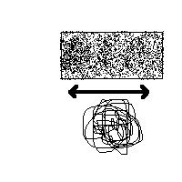
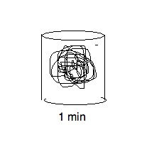
TEST: (4 steps over 2 days). Materials: Steel Wool, sand paper, Small beaker of Vinegar, Test tube, Beaker with water, ruler, permanent marker.

Step 1: Prepare the Steel Wool, remove ‘anti-rust’ coating
-Lightly rub the sand paper on the steel wool
-Put the steel wool in vinegar for about 1 min

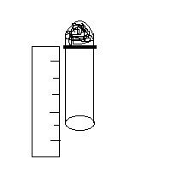
Step 2: Put the steel wool into the test tube
-Use a pencil to get the steel wool all the way to the bottom
enough so that it does not fall down when you hold the test tube
upside down.
-Use a permanent marker to mark the position of the steel wool
-Measure from your mark to the end of the test tube to figure out
how much air you will start with.

Length of test tube from line to end/ length of sample of air _______________________________
(be sure to include UNITS)

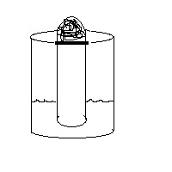
Step 3: Trap a sample of Air
-Put a small amount of water in the beaker.
-Slowly lower the upside-down test tube into the
water, trapping a sample of air inside the test tube.

WE WILL COME BACK TO CHECK IN 2 DAYS
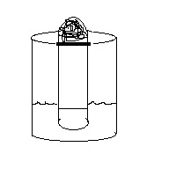
Step 4: Measure 2 days later.
-Mark with a permanent marker how far the water as
traveled up the test tube.
-Measure from the water line to the end of the tube
-Find the percent difference to calculate the percent of
oxygen that was in the original sample.

Length from line to water level/ sample of air without oxygen _______________________________
(be sure to include UNITS)

ANALYZE: To find out what percent of oxygen was in the sample, we need to find what percent of the tube is now filled with water.

Percent: _Part_ x 100% = % of part
Whole

Length from water line to end (oxygen part) x100% = Oxygen %
Length from steel line to the end (whole sample)

Fill in with your data and calculate.

____________________ x 100% = %

To find a class average for the several tests follow this equation.

Average: Sum of all entries = Average
Number of entries

Add up all the groups’ oxygen levels = Class Average Oxygen Level.
The number of groups you added up

Fill in with data and calculate

_________________________________________________ = %

COMMUNICATE CONCLUSION: Our test results show oxygen makes up _______________% of the air.

Write one questions you would want to answer next: ____________________________________________________

