NAME:_____________________________
DATE:__________________________
PER:_____________
SOLAR FUNDAMENTALS
Answer the questions and add the information to the picture as you view the solar radiation power point.
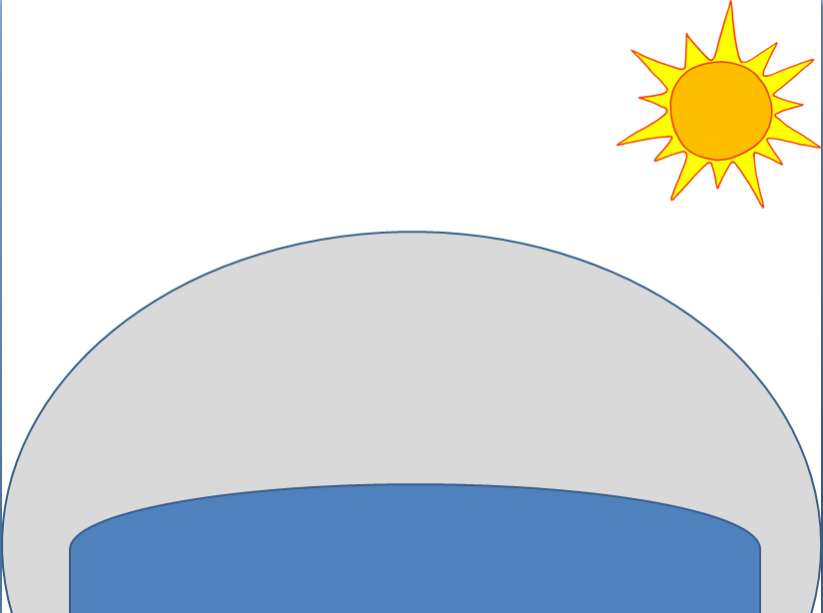
EARTH
- How much solar radiation comes from the Sun?
- How much solar radiation is scattered to space by the atmosphere?
- How much solar radiation is left?
- How much solar radiation is absorbed by the atmosphere?
- How much solar radiation is left?
- How much solar radiation is reflected by the clouds?
- How much solar radiation is left?
- How much solar radiation is absorbed by the Earth?
- How much solar radiation is left?
- How much solar radiation is reflected by the Earth?
- How much is solar radiation is left?
- What happens to the final 25% of the solar radiation?
Summary
How much of the Sun’s energy is absorbed by the Earth, clouds or atmosphere?
How much of the Sun’s energy is scattered or reflected by the Earth, clouds, or atmosphere
Draw a circle graph showing these percentages.

