Formation of the Solar System

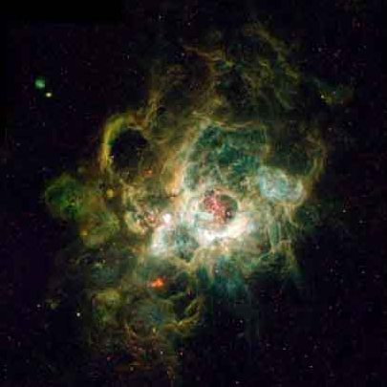
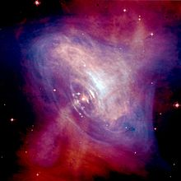

STEP 1: What is this?

STEP 1: What is this?

STEP 2 What has happened to the interstellar cloud?

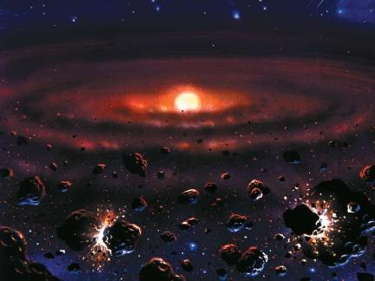
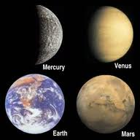

STEP 4: What are the inner planets primarily made of and why don’t they have many moons?

STEP 3: What is at the center? What will this debris compress into?

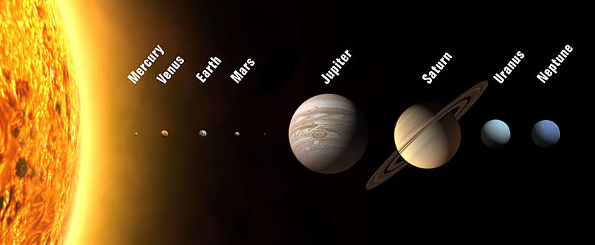

STEP 5: What are the outer planets primarily made of?

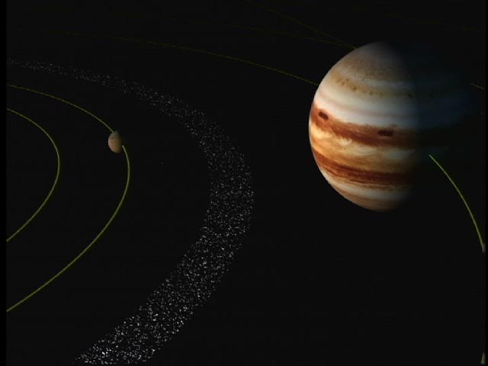

STEP 6: Why did some debris not turn into planets? What did the debris between Mars and Jupiter Form?

