PLANET TRAVEL BROUCHURE
Travel agents make brochures to help people plan vacations to exotic destinations like Hawaii, Fiji, and Finland. Travel agents in the far future may help people plan a vacation to other planets like Venus, Jupiter, and Mars! Create a travel brochure for our solar system.
- You should include the following information
Planets Name
A drawing of your planet
Distance from the Sun
Size ranking
Length of a day
Length of a year
Number of Moons
- For each make up a possible fun thing to do or see on your planet
- Suggest 2 things to remind your travelers to bring when they visit the planet. (Should they pack a bathing suit? Sweater? Or both?)
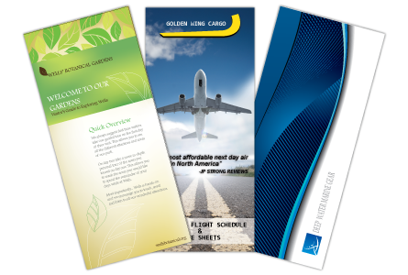
PLANET TRAVEL BROUCHURE
Travel agents make brochures to help people plan vacations to exotic destinations like Hawaii, Fiji, and Finland. Travel agents in the far future may help people plan a vacation to other planets like Venus, Jupiter, and Mars! Create a travel brochure for our solar system.
- You should include the following information
Planets Name
A drawing of your planet
Distance from the Sun
Size ranking
Length of a day
Length of a year
Number of Moons
- For each make up a possible fun thing to do or see on your planet
- Suggest 2 things to remind your travelers to bring when they visit the planet. (Should they pack a bathing suit? Sweater? Or both?)

