Terrestrial and Gas Giant Planets Venn Diagram
Name:_____________________
Date:______________
Period_____
A Venn diagram is an excellent way to compare and contrast different concepts, things, or ideas. In this diagram, we will compare the characteristics of terrestrial and gas giant planets.
Step - Give each circle a title. The left circle will be “Terrestrial Planets”. The right circle will be “Gas Giants”.
Step 2- List the characteristics for each type of planet in the appropriate circle. Any characteristic that is applicable to both types of planets goes in the center where the circles overlap.

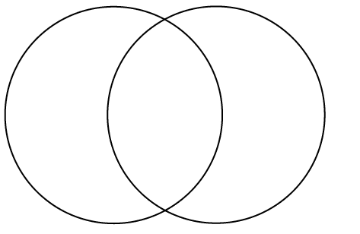
Moons Made of Rocky Material Mercury
Many Moons Made of Gas Jupiter
Few Moons/No Moons Inside of the Asteroid Belt Mars
Orbit the Sun Outside of the Asteroid Belt Saturn
Small in Size Have a orbital period Neptune
Large In Size Subject to the Sun’s Gravity Venus

