Contact Information: [Enieves@wusd.k12.ca.us](mailto:Enieves@wusd.k12.ca.us)

Paste this page in notebook as a reference

Room: 808 (916) 375-7600 ext. 2808

What’s the goal?

(Meta=goal in Spanish)

This is a proficiency- based classroom. Proficiency means internalizing the language as opposed to just memorizing words and grammar points to pass a test. Rising in proficiency means growing in your ability to communicate message more effectively. Our goal is to end Spanish 1 class in the novice mid-range.

What does Novice Mid mean?

* I can understand the text in short, simple texts or familiar texts when I listen and read in Spanish

Required Class Materials:

* Writing utensils: Both pens and pencils.
* A notebook for Spanish class
* Extra Binder paper
* A white board marker
* I can ask and answer questions on a familiar topic, using simple sentences.
* I can write or speak on familiar topics, using phrases and short, simple sentences

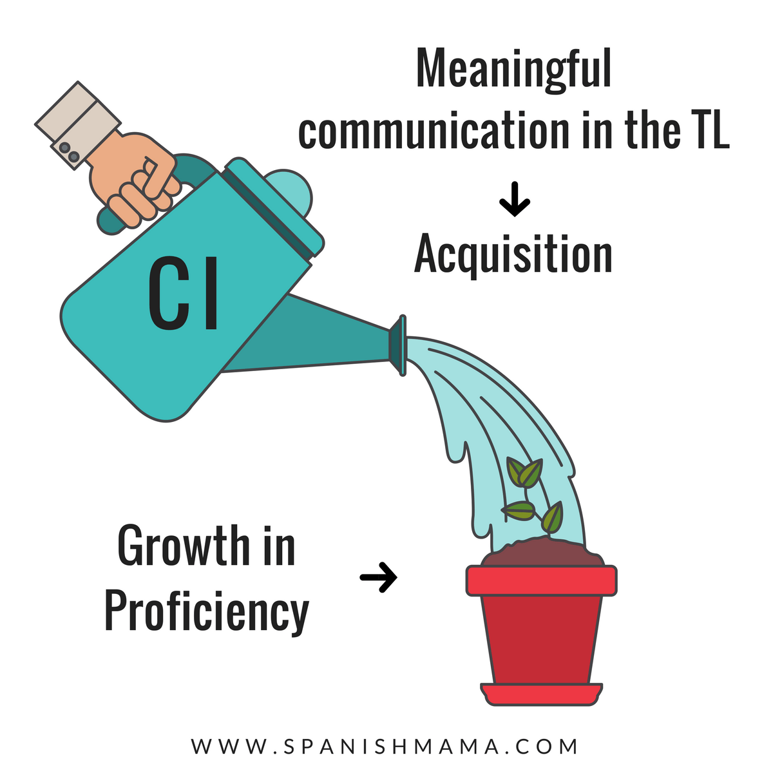What we will do?

The way to become proficient in a language is through comprehensible input. My job is to provide you with compelling and understandable language. Come to class prepared to pay attention, to listen to understand, and let me know when you need help.

Class will taught 90% in Spanish. We will listen and read short stories, listen to music, watch videos, create stories, read novels designed for your level of proficiency, play games and explore the cultures of the Spanish-Speaking world.

Parents and Guardians: Please read through this page carefully with your student and initial next to each line. Please understand that expectations are set in place to help foster a safe and open learning environment. If you have any questions or concerns please contact me directly.

**Return Signed**

**_**

**________**

**___**

Classroom Expectations, Rules, and Consequences:

1. ____ ____Be respectful- Treat others politely and kindly, choose alternative words instead of profanity, respect the teacher and your peers by asking before you take something and respecting everyone’s’ personal space.
2. ____ ____Be on time- Students are expected to be in their seats when the class bell rings.
3. ____ ____Be prepared- Students must bring the necessary class materials every day, come prepared to listen (slept enough and eaten enough) not being prepared could affect your class participation grade.
4. ____ ____No hats, hoods or sunglasses permitted in the classroom unless you directly spoke to the teacher to decide for otherwise.
5. ____ ____ No food or drinks during class. Water and healthy snacks such as fruit and vegetables are the exception, unless it becomes a distraction to other students.
6. ____ ____ There is a **NO TOLERANCE POLICY** for bullying, disrespectful behavior, offensive remarks regarding gender, race, religion, sexual orientation, intelligence, or physical appearance.  Although participation is highly encouraged in a language class, conversation is limited to the topic at hand.

**Consequences: A 3-strike system.**

1st offense: Receive a warning and fill out an incident report after class.

2nd offense: Receive a call home and fill out an additional incident report after class.

3rd offense: Request a parent conference and a referral.

Cellphone & Headphones Policy ____ ____

Students may not use cell phones during class time unless

it is being used for an in-class assignment. Cell phones and

headphones should be put away in student’s back pack

BEFORE the bell rings. Students can earn a total of 10

participation points a day. Every time they have their cell

phone out results in a deduction of 5 points each time.

Points deducted for cell phone use may not be made up.

Upon the second offense, the phone will be confiscated

and sent to the VP office.

Policy of Academic Fraud____ ____

All assignments are to be completed individually and to the best of the student’s ability.  Copying from another person or another source, including the internet an online translator), is considered cheating.  If any assignment is questionable, the student will receive a ‘’0’’ on the assignment and referred to a VP.

Homework Policy____ ____

Homework will not be assigned every night. Therefore, in-class assignments are essential for success. Occasionally, homework will be reviewing phrases and vocabulary on quizlet, finishing in-class assignments or reading in Spanish. If a student would like extra independent work, I can assign additional work.

Make-up work Policy____ ____

If a student has an unexcused absence, they are responsible for retrieving the classwork or notes that they missed. If a student does not turn in the missing work within a week, they will receive a ‘’O’’ on the assignment.

Re-take Policy____ ____

If a student scores lower than a C- on a test or quiz, they may arrange for a re-take with the teacher no later than a week after receiving the grade.

Movies rated higher than a ‘’G’’ ____ ____

Occasionally we will watch films or pieces of films that are rated higher than the MPAA ‘’G’’ rating; in class to supplement a unit or theme.  By signing this syllabus, parents’ grant permission for their students to watch these movies rated higher than a MPAA ‘’G’’ rating. If parents wish **to not** grant their student permission, please indicate that in the comments section. The student will then be assigned an alternative assignment and be sent out of class for the duration of the film.

*I certify that I have read and understand the information presented in the course syllabus. For additional questions or concerns I will contact Señorita Nieves*

Student’s name (print) _____________________________________________________

Student’s signature: _______________________________________________________

Parent or Guardian’s name (print): ____________________________________________

Parent or Guardian’s signature: _______________________________________________

Any additional comments:

(**Asking a question or leaving a comment earns extra credit for your student)

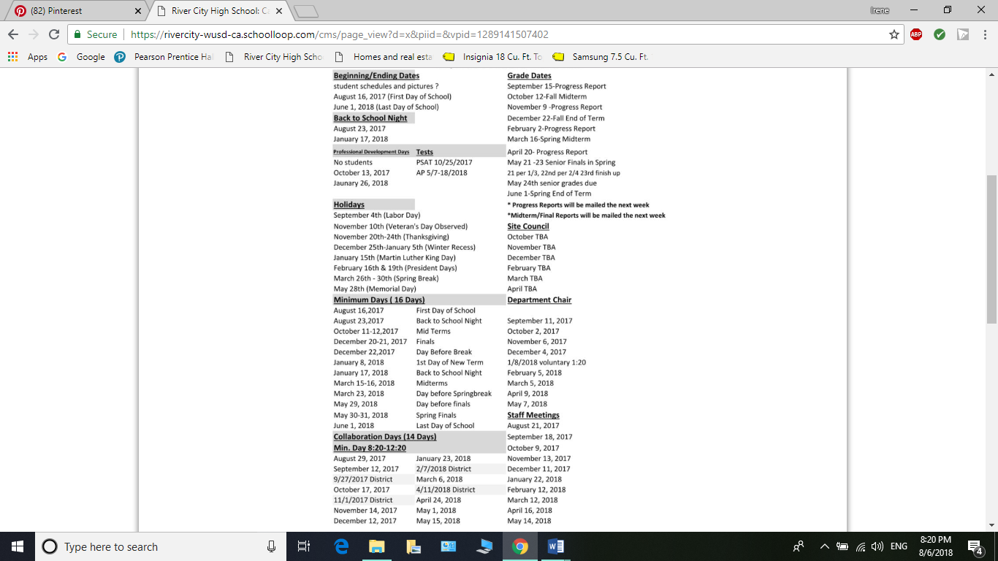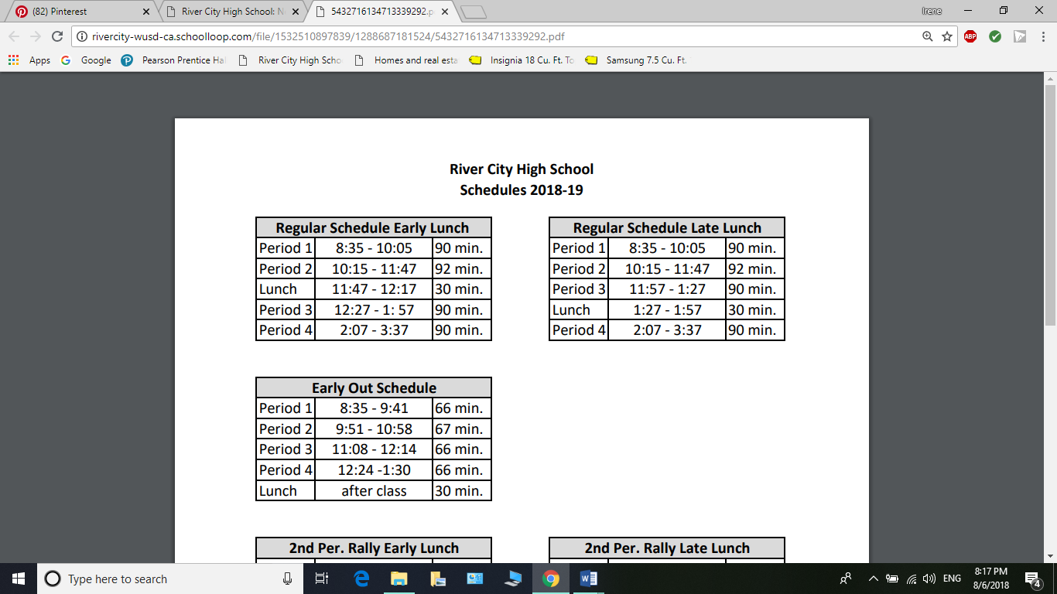Resources for Parents & Guardians