**PROPAGANDA UNIT**

Propaganda:

1. Students will read and discuss as a class (articles) The Techniques of Propaganda and Propaganda is Everywhere (pg.141-143 in reader)

2. Students will complete Propaganda Project.

3. Students will have a small propaganda quiz.

See Propaganda Power Point presentation

1. Slides/examples
2. Definitions

Activity 1: Propaganda Slide show

Have students get into small groups (3-4) for each slide, to discuss the following questions:

1. What is your immediate reaction to the slide?
2. Who do you think designed this item?
3. To whom do you think this item is directed? Who is the intended audience?
4. What is the point of this item?
5. Is it successful? Do you think it is/was successful with the intended audience? Explain.
6. What truths about the subject matter at hand do the creators of this piece not want the audience to think about? How do they distract the audience from these truths?

After groups have viewed and discussed each slide, review the slides again and ask groups to share their answers to these questions with the class. Then, ask follow up questions (to question #4):

1. How is that accomplished?
2. What does the piece feature to get the audience to think that/do that/believe that?

Activity 2:

Students are probably already aware of advertisement and/or propaganda techniques. The following slides (Propaganda Techniques definitions PowerPoint) will provide them with a formal definition of the term ‘propaganda’ and some common propaganda techniques. Have students get back in their class formation so that they can easily view the slide screen for notes. Remind students that they do not need to copy definitions word for word, but should take shortened notes in their own words. For each slide, ask students to give meanings for difficult terms out-loud. With the class, provide examples (on screen images if available) for each technique for better student understanding. Some may be harder than others!

Distribute “Propaganda Notes” handout (the seven most common types have been underlined)

Activity 4:

Exercise: Label the Propaganda and identify the devices

Activity 5:

Exercise: Propaganda Project

Activity 6:

Exercise: Propaganda Quiz

**Propaganda Notes**

Propaganda:

Propaganda Techniques and Devices:

1. **Word Games**
2. Name Calling:
3. Ad Nauseam:
4. Glittering Generalities:
5. Slogan:
6. Euphemisms:
7. **False Connections**
8. Transference:
9. Black-and-White:
10. Demonizing the Enemy:
11. Euphoria:
12. Testimonial:
13. Disinformation:
14. Logical Fallacies:
15. **Special Appeals**
16. Common Man/Plain Folks:
17. Bandwagon:
18. Appeal to Fear:
19. Snob Appeal:

Exercise: Label the following types of propaganda

1. This elegant, cashmere sweater will make you feel like the luxurious, beautiful person you are.

Type:

1. I know how hard it is to make ends meet. When I was just starting out, I struggled to pay the bills and had collectors calling me all the time. Using my program, I can help you get rid of pesky phone calls.

Type:

1. More and more students are getting the iPod touch instead of the basic iPod, or the once popular iPod nano. Do you really want to be caught with anything less than the best?

Type:

1. Stand up for your rights. Choose a candidate who has family values and supports a Democratic society through his patriotism.

Type:

1. Hello, I am Britney Spears, international pop-icon. I use a Schick razor for all my last minute, psycho breakdowns. If you use the Schick razor, I promise you will be very successful.

Type:

1. My opponent is a snake, a cheat, and a liar!

Type:

1. Senator Booshi voted against the Environmental Protection Act so he must hate trees!

Type:

Rhetorical Devices

Determine what the following slogans used as far as rhetorical devices.

1. “Plop, plop, Fizz, fizz, Oh, What a relief it is.”—Alka Seltzer. Device
2. “The milk chocolate melts in your mouth, not in your hands.”—M & M’s. Device
3. “A diamond is forever.”—De Beers. Device
4. “Unleash the Power of the Sun.”—Sunny Delight.

**Propaganda Project**

Assignment: Using Magazines, Newspapers, Online articles/sites…Locate 5 advertisements (these should be current and not one of the examples we viewed in class) and:

* Determine what type of propaganda it is
* Determine what each ad is trying to imply—what is its message?
* In your personal opinion, do you think that this is actually reaching the people? Why? (popular celebrity, aesthetically pleasing, highly sexual, shows the vice’s of man, etc)
* If you were to create your own ad/propaganda what would you try and deliver as a message?

Criteria:

* You need to create a poster
* Your poster needs to be well done, aesthetically pleasing, and not haphazardly thrown together.
* You MUST have shown proof that you know what propaganda is and how it applies to your ads.
* This project is worth 100 points

**Propaganda Quiz** Name:

Directions: Using your propaganda expertise, with each picture state what type of propaganda is being used. There could be more than one answer, so please be careful in your reasoning that you provide.

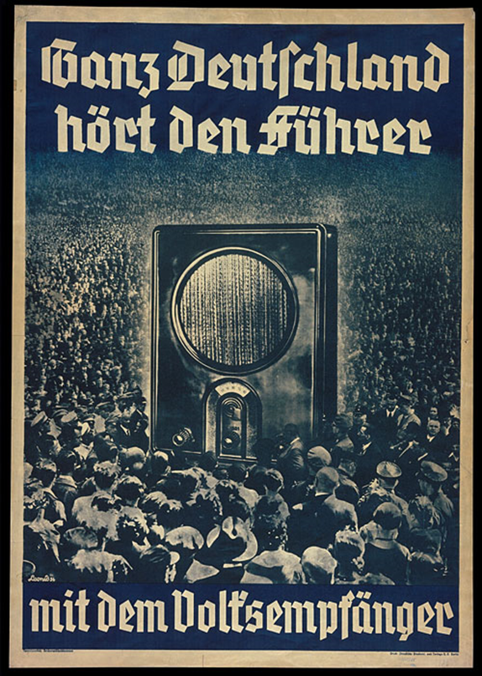 Type:

Reasoning:

1. Caption: All of Germany listens to the Fuhrer

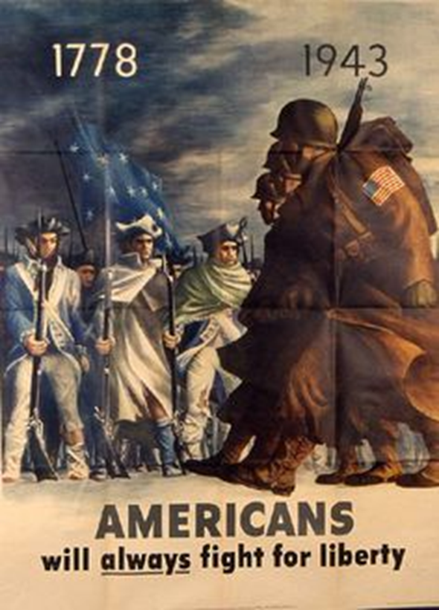

Type:

Reasoning:

2