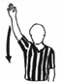  Start Clock | 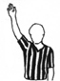  Stop Clock
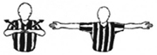  60 Sec Timeout | 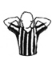  30 Sec Timeout
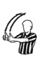  Stop Clock for Jump/Held Ball | 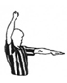  Stop Clock For Foul
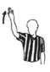
Stop Clock For Substitution
Clock:

Fouls:
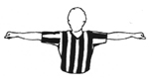  Double Foul | 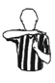  Technical Foul
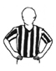  Blocking | 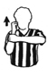  Holding
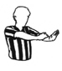  Hand Check | 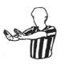  Pushing/Charging
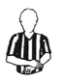  Illegal Hand Use | 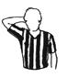  Player Control Foul
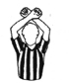
Intentional Foul

Violations:
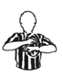  Traveling | 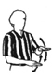  Illegal Dribble
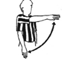  3 Sec Violation | 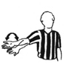  Palming the Ball
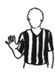
5 Sec Violation

Information:
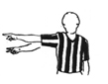  Point Scored | 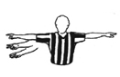  Bonus Free Throws
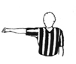  Lane Violation By Defensive Team | 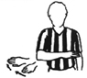  Visible Count
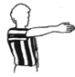  Directional Signal | 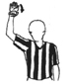  Goal Counts

